

**Name: Tetteh K. Jedidiah**

**Company: Soko Aerial**

**Email:** [**tettehjedidiah@gmail.com**](mailto:tettehjedidiah@gmail.com)

ABSTRACT: A central command and control Centre of remotely operated aircraft is a Ground Control Station (GCS). The ground control station is a hardware-based and software-based device that functions like an aircraft's cockpit. It is used for controlling drone flight and direction of drone, deciding operating parameters for aircraft, handling, tracking and regulating their sensors, monitoring cameras and other payload subsystems [1]. The aim of this article is to demonstrate how to solve the basic error that occurs when installing QGroundControl android application.

**INTRODUCTION**

Drone is a remotely piloted or controlled flying robot. They can fly autonomously through software-controlled flight plans that are embedded in their systems.

[1] A central command and control Centre of remotely operated aircraft is a Ground Control Station (GCS). GCS is usually land-based but also a misnomer since it can also be found on Navy ships. GCS is used for controlling drone flight and direction of drone, deciding operating parameters for aircraft, handling, tracking and regulating their sensors, monitoring cameras and other payload subsystems. Examples of GCS are Mission Planner, QGroundControl, ARM Planner 2 etc, to provide a graphical user interface.

[2] Drone ground control station is a hardware-based and software-based device that functions like an aircraft's cockpit.

* Hardware: The hardware segment incorporates electronic devices which play the role of the pilot in taking commands and which may be joysticks or electronic devices to create a link with the ground control systems, so that the pilot controls the action using a radio transmitter. Many devices also have 3DR radio module applications. WIFI, etc. for telemetric connection between the drone and the ground control station. The telemetry modules are directly linked to the telemetry data representation program of the ground control station.
* Software: The software is a powered pilot user interface for viewing control parameters and drone telemetry data. The program remains directly connected to the drone communications telemetry module. Typically, the user interface looks like a true aircraft cockpit for the pilot to experience real life. The program presents telemetry data from the drone in a single interface describing the drone's current state and physical condition, including the GPS location, altitude, vertical velocity, horizontal speed, heading, roll, pitch, yaw, flight mode, etc. The program also includes many modifications to adjust the IMU calibration of the drone sensor, calibration of the meter, radio calibration, flight mode, etc.

**WHAT ARE THE DIFFERENT TYPES OF GROUND CONTROL STATIONS?**

[1] There are three main types of ground control stations:

* Stationary: The trailer or a container or a command center are usually situated at stationary ground control stations.
* Shipboard: Shipboard ground control stations are located on Navy ships, usually in the data center of the ship, as their name suggests. They monitor the RPA from here, surveying and patrolling the oceans of the world and wherever the ship is docked.
* Mobile: mobile ground control stations are compact, clamshell-style hubs for proximal command and control brought into the field, often within a secure transit case that folds open to reveal butterfly displays, a keyboard, and other peripherals



*Figure 1 Shipboard GCS*

SOURCE: <https://pin.it/1QBZUnB>

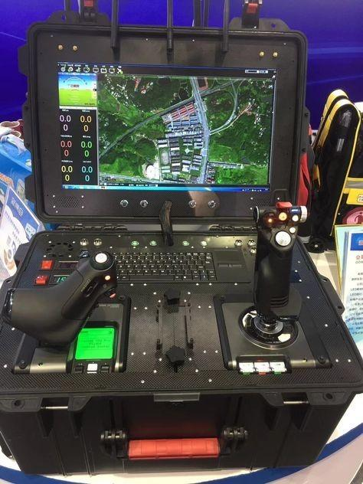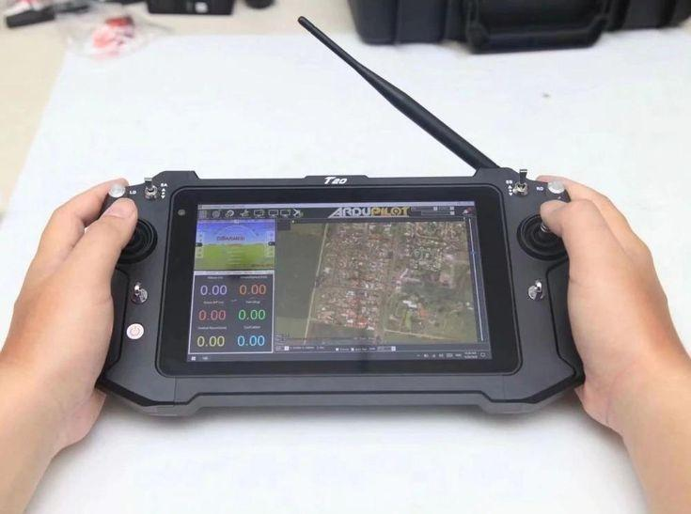

*Figure 2 Mobile GCS*

SOURCE: <https://pin.it/ykuusOT> SOURCE: <https://pin.it/1iikone>

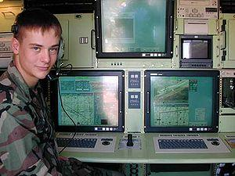

*Figure 3 Stationary GCS*

SOURCE: [3]

**QGROUND CONTROL**

[4] QGroundControl provides full flight control and mission planning for any MAVLink enabled drone. Its primary goal is ease of use for professional users and developers. All the code is open-source source, so you can contribute and evolve it as you want. [5] Firmware PX4 Pro or ArduPilot firmware can be installed on Pixhawk-family flight controller boards using QGroundControl desktop versions. QGC will install the most recent stable version of the selected autopilot by default, but you can also install beta builds, daily builds, or custom firmware files. QGroundControl can also update the firmware on SiK Radios and PX4 Flow devices.

[6] QGroundControl features:

* Full configuration support for vehicles running PX4 Pro and ArduPilot (ArduCopter,ArduPlane, ArduRover, ArduSub ) firmware
* Mission planning for autonomous flight
* Flight map display showing vehicle position, flight track, waypoints and vehicle instruments
* Video streaming with instrument display overlays
* Flight support for any MAVLink capable vehicle  
  QGroundControl is also available for Windows, MacOS, Linux and iOS.

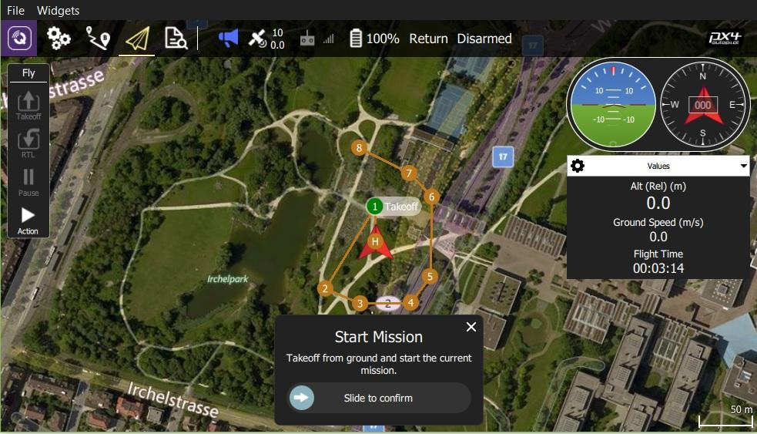

*Figure 4 QGroundControl*

SOURCE: [7]

PROBLEM

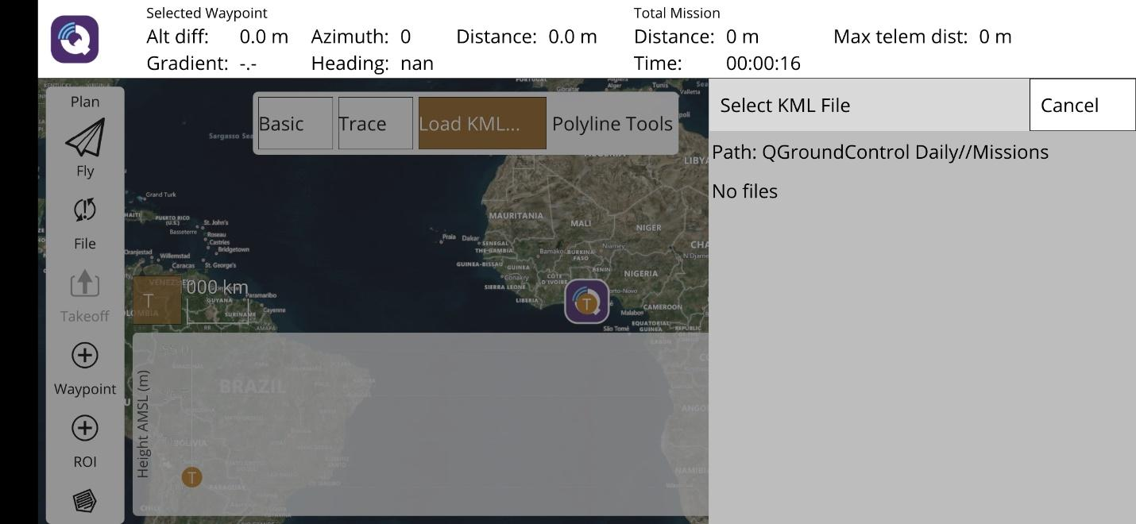

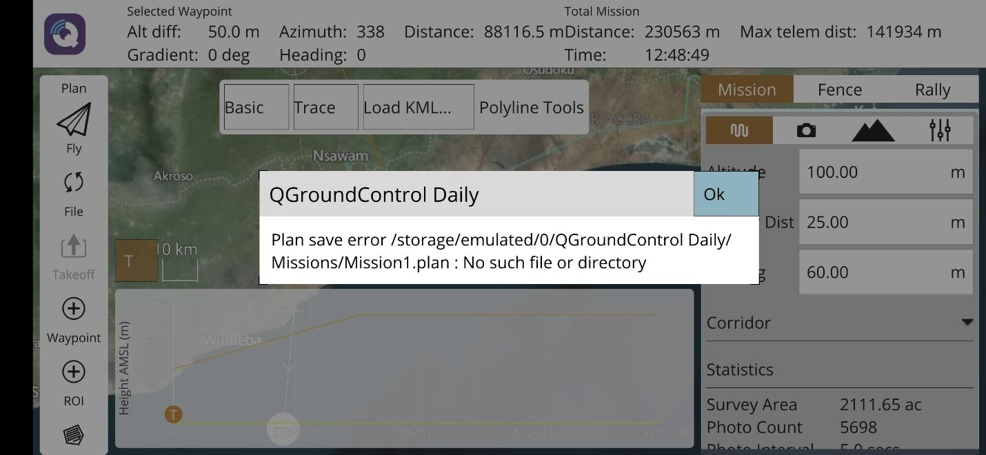

**INSTALLATION AND CONFIGURATION**

The QGroundControl is divided into two categories,

* QGroundControl build
* QGroundControl Daily build

In this article, we will focus on the QGroundControl Daily build

* Click on the link [Daily Builds · QGroundControl User Guide](https://docs.qgroundcontrol.com/master/en/releases/daily_builds.html) and download the QGroundControl64.apk
* Copy the apk file unto an android phone and install it
* Create the folder QGroundControl inside your phone’s internal memory
* Create a subfolder “Missions” inside QGroundControl folder
* Copy your kml files and paste it in the Missions folder

SOLUTION

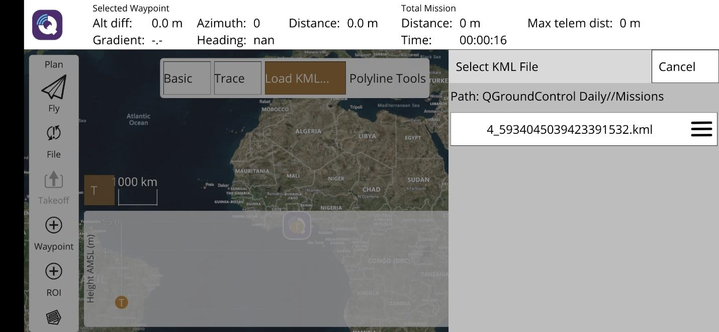

# References

|  |  |
| --- | --- |
| [1] | B. Daniel, "Ground Control Stations: The Lifeblood of Remotely Piloted Aircraft," 2 October 2020. [Online]. Available: https://www.trentonsystems.com/blog/ground-control-stations. [Accessed 11 November 2020]. |
| [2] | S. R. Haque, R. Kormokar and A. U. Zaman, "Drone ground control station with enhanced safety features," *2017 2nd International Conference for Convergence in Technology (I2CT),* pp. 1207-1210, Mumbai, 2017 . |
| [3] | [Online]. Available: https://www.google.com/url?sa=i&url=https%3A%2F%2Fen.wikipedia.org%2Fwiki%2FUAV_ground_control_station&psig=AOvVaw2LBLRt0VEU80WcjbJOyTve&ust=1605527149576000&source=images&cd=vfe&ved=2ahUKEwjcwdjsvITtAhUByRoKHQqrDlQQr4kDegUIARCdAQ. |
| [4] | Ardupilot, [Online]. Available: http://qgroundcontrol.com/. [Accessed 7 November 2020]. |
| [5] | [Online]. Available: https://theiotlearninginitiative.gitbook.io/bitol/virtual-drone-solution/ground-control-station/qgroundcontrol. |
| [6] | [Online]. Available: https://play.google.com/store/apps/details?id=org.mavlink.qgroundcontrol&hl=en&gl=US. |
| [7] | [Online]. Available: https://docs.qgroundcontrol.com/assets/fly/resume_mission_rebuilt.jpg. |
|  |  |
|  |  |